2-> diff btw abstract class and interface

Abstract class | Interface
1) Abstract class can have abstract and non-abstract methods. | Interface can have only abstract methods. Since Java 8, it can have default and static methods also.
2) Abstract class doesn't support multiple inheritance. | Interface supports multiple inheritance.
3) Abstract class can have final, non-final, static and non-static variables. | Interface has only static and final variables.
4) Abstract class can provide the implementation of interface. | Interface can't provide the implementation of abstract class.
5) The abstract keyword is used to declare abstract class. | The interface keyword is used to declare interface.
6) An abstract class can extend another Java class and implement multiple Java interfaces. | An interface can extend another Java interface only.
7) An abstract class can be extended using keyword "extends". | An interface can be implemented using keyword "implements".
8) A Java abstract class can have class members like private, protected, etc. | Members of a Java interface are public by default.
9)Example:  public abstract class Shape{  public abstract void draw();  } | Example:  public interface Drawable{  void draw();  }

2-> state different types of wrapper classes with example

The table below shows the primitive type and the equivalent wrapper class:
Primitive Data Type | Wrapper Class
byte | Byte
short | Short
int | Integer
long | Long
float | Float
double | Double
boolean | Boolean
char | Character

Example
ArrayList<int> myNumbers = new ArrayList<int>(); // Invalid
ArrayList<Integer> myNumbers = new ArrayList<Integer>(); // Valid

2-> list various functions of a container

Containers are the interface between a component and the low-level, platform-specific functionality that supports the component. Before it can be executed, a web, enterprise bean, or application client component must be assembled into a Java EE module and deployed into its container.

2-> identify the life cycle method for a servlet

The Servlet life cycle mainly goes through four stages,
- Loading a Servlet.
- Initializing the Servlet.
- Request handling.
- Destroying the Servlet.
There are three life cycle methods of a Servlet :
- init()
- service()
- destroy()

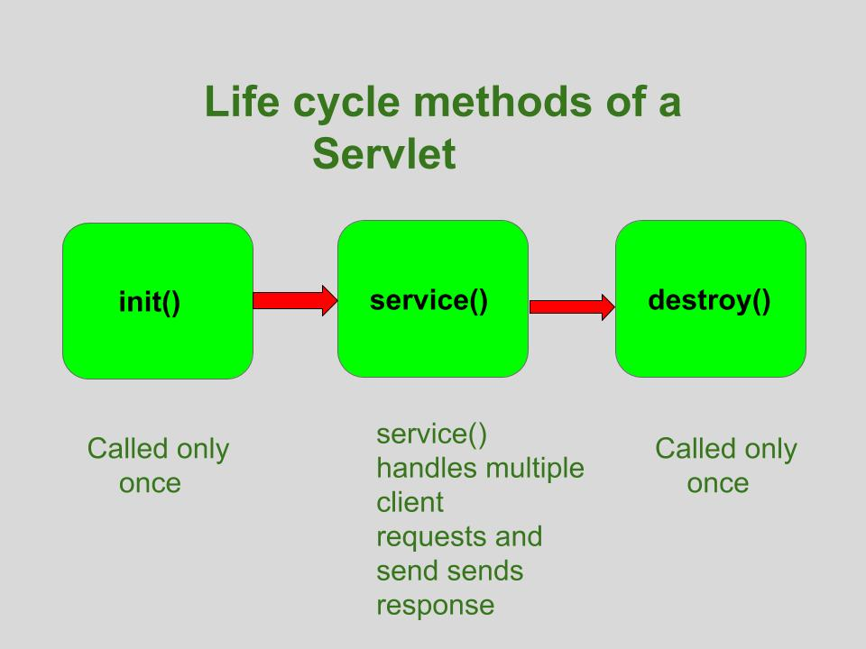

2-> define webserver, application server and how they are diff from eachother

S.NO | Web Server | Application Server
1. | Web server encompasses web container only. | While application server encompasses Web container as well as EJB container.
2. | Web server is useful or fitted for static content. | Whereas application server is fitted for dynamic content.
3. | Web server consumes or utilizes less resources. | While application server utilize more resources.
4. | Web servers arrange the run environment for web applications. | While application servers arrange the run environment for enterprises applications.
5. | In web servers, multithreading is supported. | While in application server, multithreading is not supported.
6. | Web server’s capacity is lower than application server. | While application server’s capacity is higher than web server.
7. | In web server, HTML and HTTP protocols are used. | While in this, GUI as well as HTTP and RPC/RMI protocols are used.
8. | Processes that are not resource-intensive are supported. | Processes that are resource-intensive are supported.
9. | Transactions and connection pooling is not supported. | Transactions and connection pooling is supported.
10. | The capacity of fault tolerance is low as compared to application servers. | It has high fault tolerance.
11. | Web Server examples are Apache HTTP Server , Nginx. | Application Servers example are JBoss , Glassfish.

5-> illustrate exception class hierarchy and write a program to elaborate unchecked exceptions

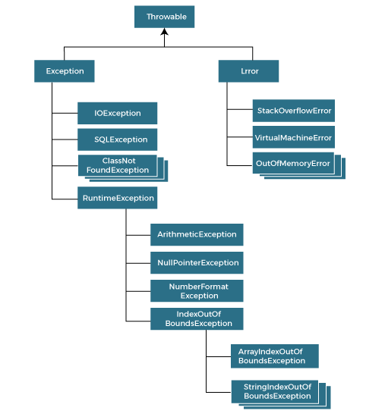
an unchecked exception represents an error in programming logic, not an erroneous situation that might reasonably occur during the proper use of an API.
Because the compiler can't anticipate logical errors that arise only at runtime, it can't check for these types of problems at compile time. That's why they are called "unchecked" exceptions.
The following example contrasts checked and unchecked exceptions.
public static void main(String[] args) {

/* checked vs unchecked exception example */
try {
Class.forName("com.mcnz.Example");
} catch (ClassNotFoundException e) {
System.out.println("Class was not found.");
}

String input = null;
input.length(); // throws an unchecked exception

}

5-> elaborate diff steps involved in java db connectivity with the help of suitable program

1) Register the driver class
The forName() method of Class class is used to register the driver class. This method is used to dynamically load the driver class.

Syntax of forName() method
- public static void forName(String className)throws ClassNotFoundException

Example to register the OracleDriver class
Here, Java program is loading oracle driver to esteblish database connection.
- Class.forName("oracle.jdbc.driver.OracleDriver");

2) Create the connection object
The getConnection() method of DriverManager class is used to establish connection with the database.

Syntax of getConnection() method
- 1) public static Connection getConnection(String url)throws SQLException
- 2) public static Connection getConnection(String url,String name,String password)
- throws SQLException

Example to establish connection with the Oracle database
- Connection con=DriverManager.getConnection(
- "jdbc:oracle:thin:@localhost:1521:xe","system","password");

3) Create the Statement object
The createStatement() method of Connection interface is used to create statement. The object of statement is responsible to execute queries with the database.

Syntax of createStatement() method
- public Statement createStatement()throws SQLException

Example to create the statement object
- Statement stmt=con.createStatement();

4) Execute the query
The executeQuery() method of Statement interface is used to execute queries to the database. This method returns the object of ResultSet that can be used to get all the records of a table.

Syntax of executeQuery() method
- public ResultSet executeQuery(String sql)throws SQLException

Example to execute query
- ResultSet rs=stmt.executeQuery("select * from emp");

- while(rs.next()){
- System.out.println(rs.getInt(1)+" "+rs.getString(2));
- }

5) Close the connection object
By closing connection object statement and ResultSet will be closed automatically. The close() method of Connection interface is used to close the connection.

Syntax of close() method
- public void close()throws SQLException

Example to close connection
- con.close();

5-> expalain importance of xml parsing and interfaces of dom parser

XML Parser provides a way to access or modify data in an XML document. Java provides multiple options to parse XML documents. Following are the various types of parsers which are commonly used to parse XML documents.
- Dom Parser − Parses an XML document by loading the complete contents of the document and creating its complete hierarchical tree in memory.
- SAX Parser − Parses an XML document on event-based triggers. Does not load the complete document into the memory.
- JDOM Parser − Parses an XML document in a similar fashion to DOM parser but in an easier way.
- StAX Parser − Parses an XML document in a similar fashion to SAX parser but in a more efficient way.
- XPath Parser − Parses an XML document based on expression and is used extensively in conjunction with XSLT.
- DOM4J Parser − A java library to parse XML, XPath, and XSLT using Java Collections Framework. It provides support for DOM, SAX, and JAXP.
The Document Object Model (DOM) is an official recommendation of the World Wide Web Consortium (W3C). It defines an interface that enables programs to access and update the style, structure, and contents of XML documents. XML parsers that support DOM implement this interface.

DOM interfaces
The DOM defines several Java interfaces. Here are the most common interfaces −
- Node − The base datatype of the DOM.
- Element − The vast majority of the objects you'll deal with are Elements.
- Attr − Represents an attribute of an element.
- Text − The actual content of an Element or Attr.
- Document − Represents the entire XML document. A Document object is often referred to as a DOM tree.

5-> examine the signinfance of document type definition. how we can use dtd in xml program.

DTD stands for Document Type Definition. It defines the legal building blocks of an XML document. It is used to define document structure with a list of legal elements and attributes.
Its main purpose is to define the structure of an XML document. It contains a list of legal elements and define the structure with the help of them.
Let's take an example of well-formed and valid XML document. It follows all the rules of DTD.
employee.xml
- <?xml version="1.0"?>
- <!DOCTYPE employee SYSTEM "employee.dtd">
- <employee>
- <firstname>vimal</firstname>
- <lastname>jaiswal</lastname>
- <email>vimal@javatpoint.com</email>
- </employee>
In the above example, the DOCTYPE declaration refers to an external DTD file. The content of the file is shown in below paragraph.
employee.dtd
- <!ELEMENT employee (firstname,lastname,email)>
- <!ELEMENT firstname (#PCDATA)>
- <!ELEMENT lastname (#PCDATA)>
- <!ELEMENT email (#PCDATA)>
A doctype declaration can also define special strings that can be used in the XML file.
An entity has three parts:
- An ampersand (&)
- An entity name
- A semicolon (;)
Syntax to declare entity:
- <!ENTITY entity-name "entity-value">
Let's see a code to define the ENTITY in doctype declaration.
author.xml
- <?xml version="1.0" standalone="yes" ?>
- <!DOCTYPE author [
- <!ELEMENT author (#PCDATA)>
- <!ENTITY sj "Sonoo Jaiswal">
- ]>
- <author>&sj;</author>

10-> demonstrate with the help of program the visiblity of each access modifier outside class and outside package.

In Java, access modifiers are used to set the accessibility (visibility) of classes, interfaces, variables, methods, constructors, data members, and the setter methods. For example,
class Animal {
public void method1() {...}

private void method2() {...}
}
There are four access modifiers keywords in Java and they are:

Default Access Modifier
If we do not explicitly specify any access modifier for classes, methods, variables, etc, then by default the default access modifier is considered. For example,
package defaultPackage;
class Logger {
void message(){
System.out.println("This is a message");
}
}
Here, the Logger class has the default access modifier. And the class is visible to all the classes that belong to the defaultPackage package. However, if we try to use the Logger class in another class outside of defaultPackage, we will get a compilation error.

Private Access Modifier
When variables and methods are declared private, they cannot be accessed outside of the class. For example,
class Data {
// private variable
private String name;
}

public class Main {
public static void main(String[] main){

// create an object of Data
Data d = new Data();

// access private variable and field from another class
d.name = "Programiz";
}
}
In the above example, we have declared a private variable named name. When we run the program, we will get the following error:
Main.java:18: error: name has private access in Data
d.name = "Programiz";
^
The error is generated because we are trying to access the private variable of the Data class from the Main class.

Protected Access Modifier
When methods and data members are declared protected, we can access them within the same package as well as from subclasses. For example,
class Animal {
// protected method
protected void display() {
System.out.println("I am an animal");
}
}

class Dog extends Animal {
public static void main(String[] args) {

// create an object of Dog class
Dog dog = new Dog();
// access protected method
dog.display();
}
}
Output:
I am an animal
In the above example, we have a protected method named display() inside the Animal class. The Animal class is inherited by the Dog class. To learn more about inheritance, visit Java Inheritance.
We then created an object dog of the Dog class. Using the object we tried to access the protected method of the parent class.
Since protected methods can be accessed from the child classes, we are able to access the method of Animal class from the Dog class.

Public Access Modifier
When methods, variables, classes, and so on are declared public, then we can access them from anywhere. The public access modifier has no scope restriction. For example,
// Animal.java file
// public class
public class Animal {
// public variable
public int legCount;

// public method
public void display() {
System.out.println("I am an animal.");
System.out.println("I have " + legCount + " legs.");
}
}

// Main.java
public class Main {
public static void main( String[] args ) {
// accessing the public class
Animal animal = new Animal();

// accessing the public variable
animal.legCount = 4;
// accessing the public method
animal.display();
}
}
Output:
I am an animal.
I have 4 legs.
Here,
- The public class Animal is accessed from the Main class.
- The public variable legCount is accessed from the Main class.
- The public method display() is accessed from the Main class.

10 -> explain how thread can be created in java. demonstrate diff techniques of thread synchronisation with the help of program

There are two ways to create a thread:
- By extending Thread class
- By implementing Runnable interface.

1) Java Thread Example by extending Thread class
FileName: Multi.java
- class Multi extends Thread{
- public void run(){
- System.out.println("thread is running...");
- }
- public static void main(String args[]){
- Multi t1=new Multi();
- t1.start();
- }
- }
Output:
thread is running...

2) Java Thread Example by implementing Runnable interface
FileName: Multi3.java
- class Multi3 implements Runnable{
- public void run(){
- System.out.println("thread is running...");
- }

- public static void main(String args[]){
- Multi3 m1=new Multi3();
- Thread t1 =new Thread(m1); // Using the constructor Thread(Runnable r)
- t1.start();
- }
- }
Output:
thread is running...

There are two types of thread synchronization mutual exclusive and inter-thread communication.
- Mutual Exclusive
  - Synchronized method.
  - Synchronized block.
  - Static synchronization.
- Cooperation (Inter-thread communication in java)
If you declare any method as synchronized, it is known as synchronized method.
Synchronized method is used to lock an object for any shared resource.
When a thread invokes a synchronized method, it automatically acquires the lock for that object and releases it when the thread completes its task.
TestSynchronization2.java
- //example of java synchronized method
- class Table{
- synchronized void printTable(int n){//synchronized method
- for(int i=1;i<=5;i++){
- System.out.println(n*i);
- try{
- Thread.sleep(400);
- }catch(Exception e){System.out.println(e);}
- }

- }
- }

- class MyThread1 extends Thread{
- Table t;
- MyThread1(Table t){
- this.t=t;
- }
- public void run(){
- t.printTable(5);
- }

- }
- class MyThread2 extends Thread{
- Table t;
- MyThread2(Table t){
- this.t=t;
- }
- public void run(){
- t.printTable(100);
- }
- }

- public class TestSynchronization2{
- public static void main(String args[]){
- Table obj = new Table();//only one object
- MyThread1 t1=new MyThread1(obj);
- MyThread2 t2=new MyThread2(obj);
- t1.start();
- t2.start();
- }
- }
Output:
5
10
15
20
25
100
200
300
400
500

10-> analyse the requirement of scriptlet in jsp with appropriate code. elaborate diff types of scripting elements

JSP (Java Server Pages) Scriptlet is a tag that is used to write java source code to implement business logic. This Scriptlet tag is declared inside the _jspService() method. _jspService()method always create new object for every new request. So as Scriptlet tag is inside the _jspService() method it will also create new object for every new request.

JSP Scriptlet used within <% %>(Scriptlet) tag. This will allow to include entire Java source code.
Syntax:
<% Java Source code %>
Like
<%
out.println(“content”);
<%>
Explanation:
- Scriptlet tag start with <% tag and ends with%> tag.
- Plain Java for printing the output we write System.out.println() but in case of JSP we just write out.println() and System class automatically provided by JSP web container.
- In JSP there are 9 implicit objects are there out is one among them.
Example
<%@ page language="java" contentType="text/html; charset=ISO-8859-1"
pageEncoding="ISO-8859-1"%>
<!DOCTYPE html PUBLIC "-//W3C//DTD HTML 4.01 Transitional//EN" "http://www.w3.org/TR/html4/loose.dtd">
<html>
<head>
<!-- CSS Styles -->
<style type="text/css">
h1
{
color:green;
text-align: center;
}
p
{
color: blue;
font-size: 25px;
border: solid 3px brown;
}
</style>
<meta http-equiv="Content-Type" content="text/html; charset=ISO-8859-1">
<title>JSP Scriptlet Tag</title>
</head>
<body>
<h1>Introduction JSP Scriptlet Tag</h1>
<p>
<!--scriptlet tag -->
<%
//out is implicit object of JSP
out.print(
"JSP (Java Server Pages) Scriptlet is a tag used write java source code to implement business logic. This Scriptlet tag declared inside the _jspService() method. _jspService() method always create new object for every new request. So as Scriptlet tag is inside the _jspService() method it will also create new object for every new request. There 3 types of tag in JSP 1. Declaration tag 2. Expression tag 3. Scriptlet tag Each tag has their own specification to insert the code in the JSP application. Declaration tag is used to used to declare variables and methods. Expression tag is used to display output of the JSP application. Scriptlet tag is used for include Java source code.");
%>
</p>
</body>
</html>
Output:
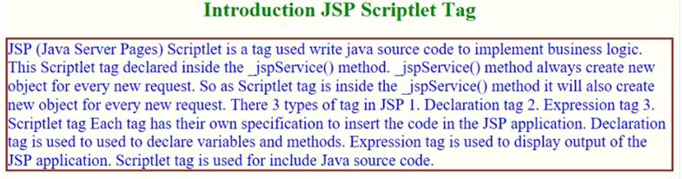

There are five different types of scripting elements

JSP Comment
JSP Comment is used when you are creating a JSP page and want to put in comments about what you are doing. JSP comments are only seen in the JSP page. These comments are not included in servlet source code during translation phase, nor they appear in the HTTP response. Syntax of JSP comment is as follows :
<%-- JSP comment --%>

JSP Scriptlet Tag
Scriptlet Tag allows you to write java code inside JSP page. Scriptlet tag implements the _jspService method functionality by writing script/java code. Syntax of Scriptlet Tag is as follows :
<% JAVA CODE %>

JSP Declaration Tag
We know that at the end a JSP page is translated into Servlet class. So when we declare a variable or method in JSP inside Declaration Tag, it means the declaration is made inside the Servlet class but outside the service(or any other) method. You can declare static member, instance variable and methods inside Declaration Tag. Syntax of Declaration Tag :
<%! declaration %>

JSP Directive Tag
Directive Tag gives special instruction to Web Container at the time of page translation. Directive tags are of three types: page, include and taglib.
Directive | Description
<%@ page ... %> | defines page dependent properties such as language, session, errorPage etc.
<%@ include ... %> | defines file to be included.
<%@ taglib ... %> | declares tag library used in the page

JSP Expression Tag
Expression Tag is used to print out java language expression that is put between the tags. An expression tag can hold any java language expression that can be used as an argument to the out.print() method. Syntax of Expression Tag
<%= Java Expression %>

